# CS 340 README Template

*Use this template to complete your README file. When completing the template, keep the headings as they are so that your document has a clear organization. Remove the italicized prompt text after you have completed each section for a polished final document.*

## About the Project/Project Title

*Our client, Grazioso Salvare, has tasked us at Global Rain with creating full stack web application for their Innovative international rescue-animal training company. The purpose of this project is to provide users with an easy-to-use interface created through Dash that grants users the ability to identify and categorize available dogs using existing data from animal shelter stored in a database powered by MongoDB using functionality from a CRUD Python Module. Users of this applications will have the ability to import, manage, and maintain data in a database as well as sort, filter, and have visual data table, geolocation map, and pie chart representation of the categorization of their data. More specifically users will be able to efficiently filter and sort through dog breeds categorized under different types of rescues such as water, mountain or wilderness, and disaster or individual tracking.*

## Motivation

*In this project, we will work towards building an application that has the ability to work with data from five different animal shelters across Texas. The software pattern used for the development of this multi-tier application is the Model View Controller (MVC) design, which constructs functionality between a user, controller, and data model with MongoDB representing the model, the Dash Framework representing the view, and the callbacks that query the database and trigger the functionality as the controller.*

*MongoDB, as the model component, is the base level used to handle the application's backend, which includes data integration, storage, and manipulation, while the creation of a custom tested CRUD Python module provides basic capabilities for manipulating data and returning it to the user. MongoDB is an excellent choice as it provides for users an easy and efficient way to create a database from a csv file. Users will find it is less cumbersome to enact CRUD functionality in a MongoDB database by interfacing with the middle-ware of the application, Python, using the Python driver, PyMongo. At the Glue level, the CRUD Python module facilitates a user’s ability to not only enact the basic functions needed to organize and maintain documents in a database, but they will also find it convenient to test and verify the success of the actions taken within their database.*

*Dash, as the view and controller structure for the web application, is used to handle the application’s front-end to design a user-interface that is able to connect to MongoDB through the custom Python module. Dash, as the client level of the Python web application, is an open-source Python framework that will make the program more accessible and easier to navigate for users. As framework that excels in building web analytic applications best suited in Python, Dash is the optimal solution for this project as it facilitates the creation of highly customizable interfaces that will allow us, through the use of Dash Core Components, to create interactive and dynamic visual representations of data sets that are easily manipulated by users.*

## Getting Started

*To get a local copy up and running, follow these simple example steps:*

1. *Access your Linux Terminal to initiate the mongo server. It is helpful to run commands on your Linux Terminal like “mongod_ctl status” to ensure mongo is not currently running.*
2. *The CVS file for the Austin Animal Center Outcome (ACC database) must be imported and an index created to parse the data store within the document, as shown below.* 
   1. *Before using the import tool to import data from the aac_shelt_outcomes.csv file, Mongo must be initiated so that the port number specific to your system may be noted. It is recommended you run Mongo using “ mongod_ctl start-noauth” to prevent any troubleshooting you may experience due to authentication.*

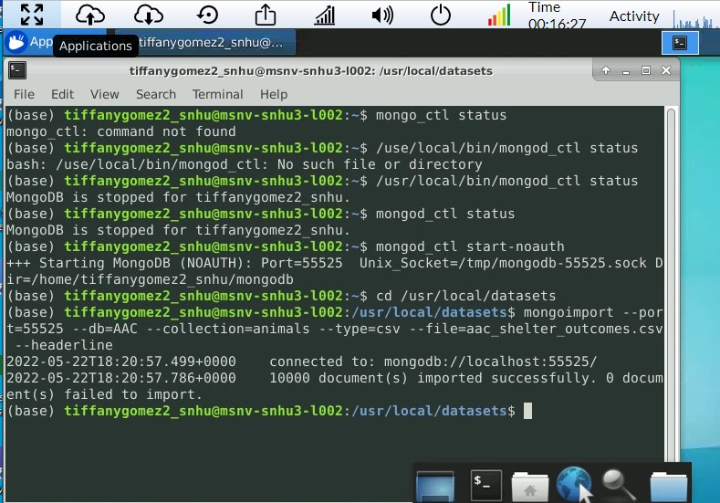

1. *User authentication must be enabled through the creation of a new user using a username and password to access the database with the privileges specifically assigned to the user. For example, it is recommended to create an administrator account and a user account with different privileges as illustrated below.*
   1. *Spelling and spacing in key, so make sure you save your login credentials exactly as they are inputted so that your authentication does not fail.*
   2. *When verifying the successful creation of your user account, do not forget to stop your mongo instance, close your terminal, check the status to ensure your instance has stopped, and then attempt login.*

* Successful creation and login of an administrator account

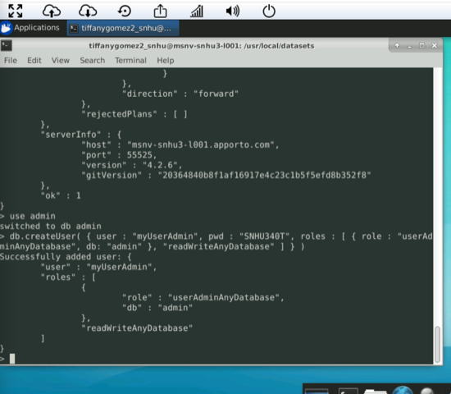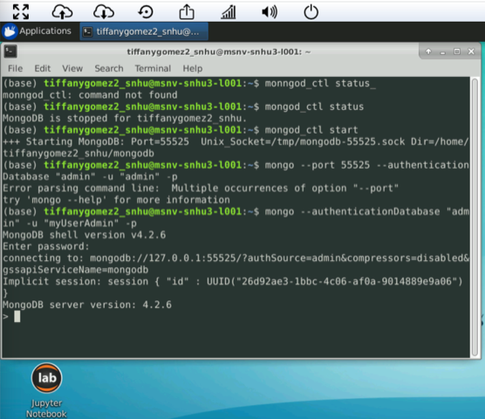

* Successful creation and login of a user account

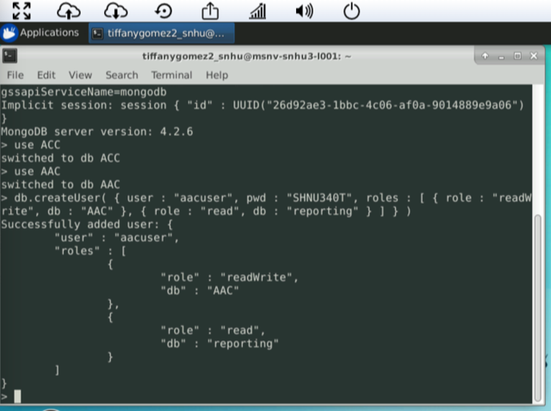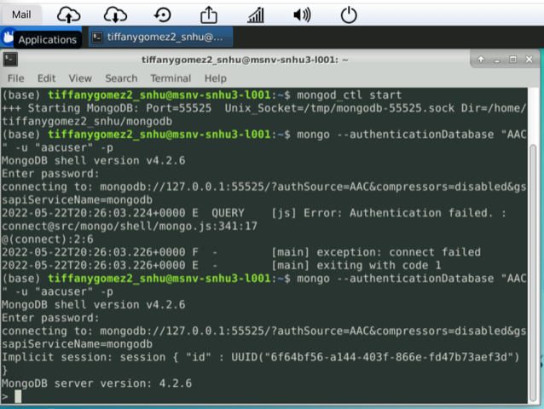

1. *After successfully logging into MongoDB, the next step is to customize the Python CRUD module to access the database. You can now open Jupyter Notebook to download the Python code (animal_shelter.py) and Python Testing Script (test. Ipynb). Python was used to implement the create, read, update, and delete (CRUD) functionality that allows a user to create and store new database documents, query for documents using specific criteria, search for a specific document to update its content, and delete a document. The Python Testing Script can be used to test the code and ensure the successfully deployment of basic CRUD functionality is being reflected in the database, and no errors are returned unless purposely called.*

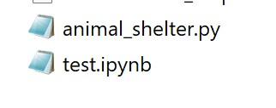

* 1. *For those new to Jupyter, ensure you refresh when editing the python code and you run through every line in order of sequence every time you edit any portion of the python testing script to avoid any errors.*
  2. *Ensure the port number of the localhost in the Python code for animal_shelter.py is updated to reflect yours.*

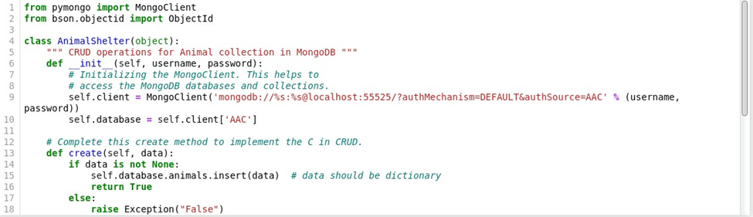

* 1. *Ensure the username and password in test.ipynb is updated to reflect the username and password created.*

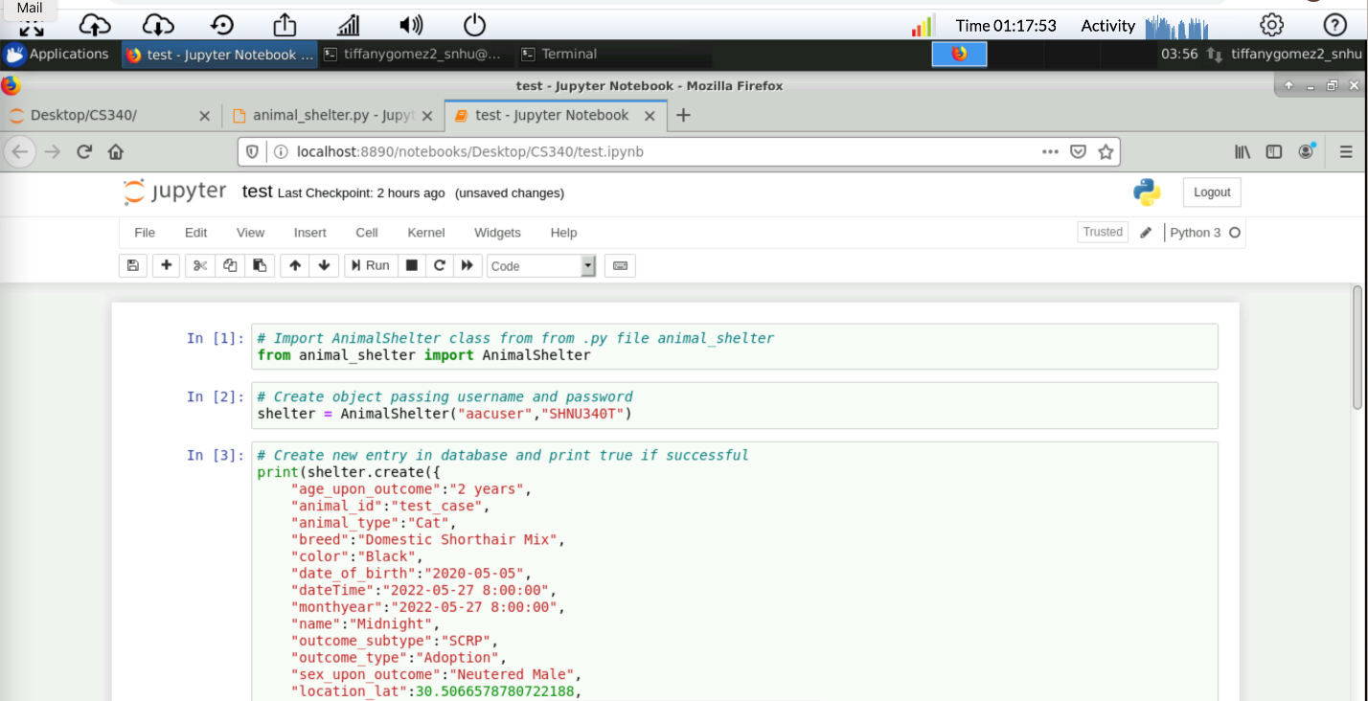

1. *After correctly establishing the back-end of the application and testing the Python module’s functionality and connection to the MongoDB database, you should now upload and open in Jupyter Notebook the file ProjectTwoDashboard.ipynb to begin creating the front-end interfacing of the application using the Dash framework.*

**

* 1. *Since Dash uses established connection between MongoDB and the CRUD Python Module to create a front-end system that allows users to use the basic CRUD function from the database efficiently:*
     1. *Ensure the username and password in ProjectTwoDashboard.ipynb is updated to reflect the username and password created and used in test.ipynb.*

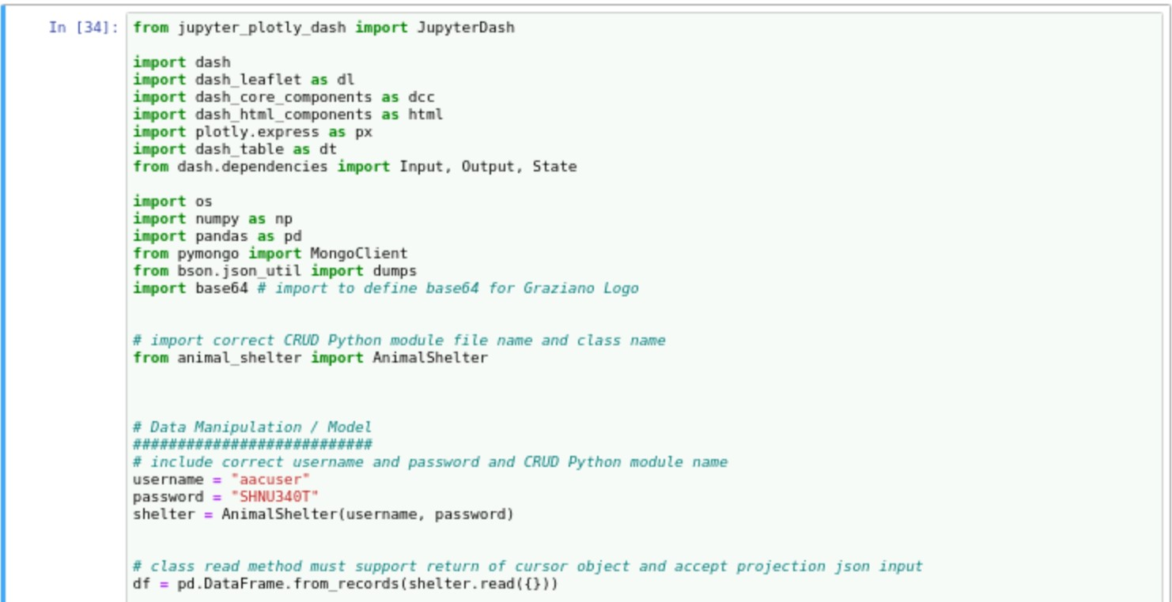

* + 1. *Ensure your class name and file name match that of your CRUD Python model.*

**

* + 1. *Ensure Dash, its core and html components, plotly, dash table, dependencies, os, numpy, pandas, pymongo, and Jason dumps are imported.*

**

* + - 1. *Troubleshoot: You may encounter an error when adding the client’s logo. This is solved by importing base64 to define base64 set in the enconded_image.*

**

* 1. *It is recommended that at this stage you check that status of your MongoDB server to ensure it is still running.*

## Installation

* *Download the provided .py and .ipynb files (as shown Getting Started).*
* *Tool: Latest version of MongoDB - a NoSQL database that can handling highly intensive loads, so it is perfect for storing the data from the animal shelters and providing the functionality to manipulate the data within.* 
  + *The MongoDB import tool is necessary to import the CSV file into the correct database. To access the import tool a Linux Terminal was used. Your system’s terminal is necessary for implementing the steps in Getting Started in order to access the databases in MongoDB.*
  + *For more information and installation instructions visit:* [*https://docs.mongodb.com/manual/installations/*](https://docs.mongodb.com/manual/installations/)*.*
* *Tool: PyMongo - the MongoDB Python Driver chosen as it allows us to create an application that can connect, store, and retrieve data from our MongoDB database. As the application’s middle tier that connects the client side (Dash Framework – controller and view) to the server side (MongoDB – model), the Python module requires pymongo and objectid to the import the data from MongoDB in order to have full access to MongoDB’s functionality.* 
  + *It has its own ObjectId class to handle each document’s object id.*

**

* + *For more information and installation instructions visit:* [*https://pymongo.readthedocs.io/en/stable/*](https://pymongo.readthedocs.io/en/stable/)
* *Tool: Jupyter Notebook - used to test the functionality of the CRUD class. The CRUD Python module must be uploaded into Jupyter Notebook to run testing for the backend of the application. For the front-end interfacing of the application, Jupyter Notebook to create and test the Python code for the interactive dashboard.*
  + *MongoDB must be running in your system’s terminal before opening and running test.*
  + *Ensure you have started the instance (recommended start-noauth) and have access to the database. After starting mongo issue the following mongo commands in your terminal:*
    - *Show dbs*
    - *Use AAC*
    - *Show collections*
  + For more information and installation instructions visit: [*https://jupyter.org/install*](https://jupyter.org/install)*.*
* *Tool: Dash is an open-source Python framework, commonly used for analytical web applications, that allows for the simplification of a front-end interface through our data driven system. Dash Framework simplifies the creation of a user-friendly dashboard by providing a vast library of Dash Core Components that includes widgets to filter, sort, view, and create tables and charts for the stored data.*
  + *The widgets and filter option presented to users are tied to specific queries that are responsible for initiating the Python Module to activate database requests that are instantly returned to users.*
  + *For more information and installation instructions visit:* [*https://dash.plotly.com/installation*](https://dash.plotly.com/installation)
  + *Plotly Dash and Dash Leaflet are charting tools used to display and populate a Data Table, a pie chart with the percentage of each breed available based on the query, and a map that shows the location of the dogs in the search. For more information visit:* [*https://dash-leaflet.herokuapp.com/*](https://dash-leaflet.herokuapp.com/) *and* [Dash DataTable | Dash for Python Documentation | Plotly](https://dash.plotly.com/datatable).
    - *Note this documentation is a great source for templates to use when formatting callbacks, filter option features for the data table, and formatting graphs and charts.*
  + *Pandas is a Python Data Analysis Library used for creating the data frames used in this application. For more information visit:* [*https://pandas.pydata.org/*](https://pandas.pydata.org/)
    - *Note that while in the MVC design patter, the library is part of the controller as it provides the structure that translates between MongoDB and Dash data types. It is also consider part of the “Glue” level as it is dependent on other coding structures to function for data visualization.*

## Usage

*Use this space to show useful examples of how your project works and how it can be used. Be sure to include examples of your code, tests, and screenshots.*

### Code Example

*Following a MVC software design pattern for this multi-tier application built upon a MongoDB database, a Dash Framework interface, and a CRUD Python module, illustrated below is the CRUD Python Module, the Python Script, and the code for the Dash framework. As you look through the code and the working visualization of the application, keep the functions of each tier in mind.*

**Python CRUD Class**

*The CRUD Python Module, aside from establishing the application’s basic CRUD functions, is what connects users accessing the dashboard to the MongoDB database. It verifies user authentication of username and password to the proper database with proper access rights.*

1. *Your code must include the chosen MongoDB driver PyMongo to start an instance and its Objectid class to allow us to connect to our database. Include the JSON tool to produce a result in JSON format later on in our code.*

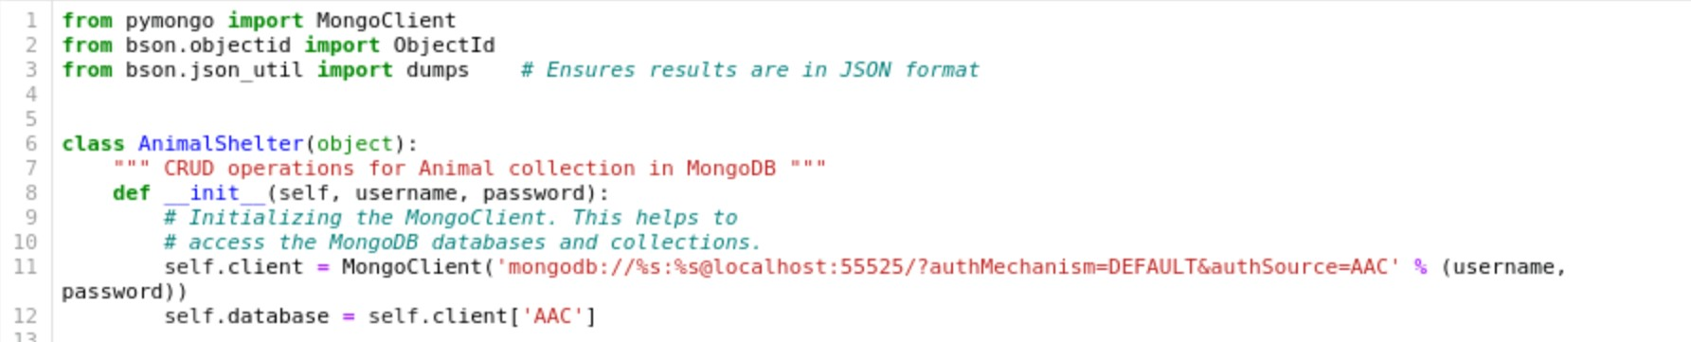

1. *The __init__ function initializes the MongoClient to access the AAC database and animal collection using a user’s username, password, and local host port number.*

**

1. *The create function allows users to create a document with their needed data. Through a conditional statement, the function verifies that the data being passed is not none before using insert() to add the new document to the database and returning True. The function will otherwise return False if the creation of a new document entry was unsuccessful.*

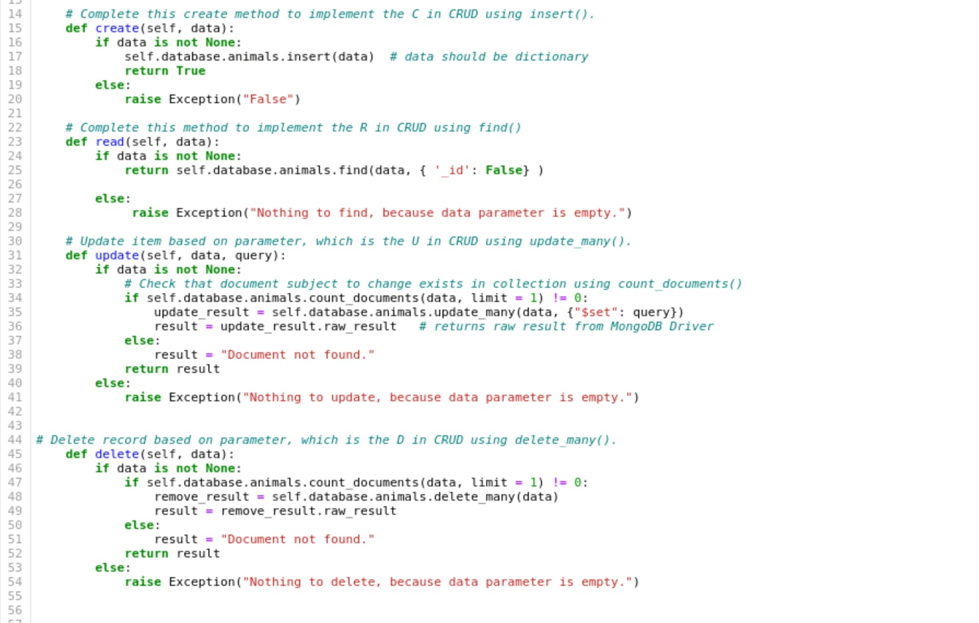

1. *The read function allows users to query the database for a specific document(s) that has a specific criterion. Through a conditional statement, the function verifies the queried data is not none before using find() to find documents with the specified criteria. If no data is specified to query, then the function will raise an exception. Note, {‘_id’:false} is recommended to avoid objectid interference in the results.*

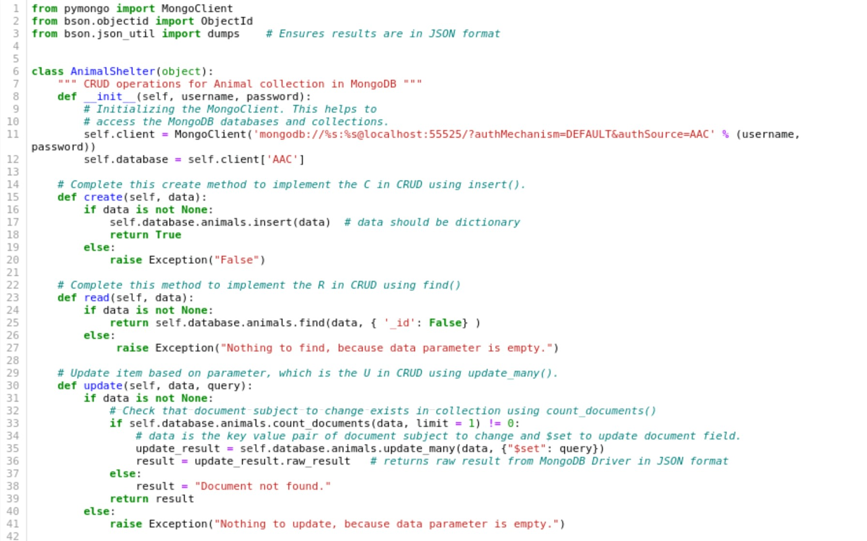

1. *The update function passes a parameter to query for the document(s) needed to be updated and a parameter that holds the new value for the updated criteria. Through a conditional statement, the function verifies the data used to search for a document(s) and the query to update to is not none, otherwise raising an exception. The function has a nested statement to ensures that the document searched for exists within the database, before performing the action of updating a criteria of the document queried with update_many(), by using count_document(). If so, the data key values for the criteria that identified a document to update, and the key values for query that identify the criteria to update with $set are used. To confirm the document updated, the results need to include raw_result() to be in JSON format or else you will get a simplepython.result objectid message.*

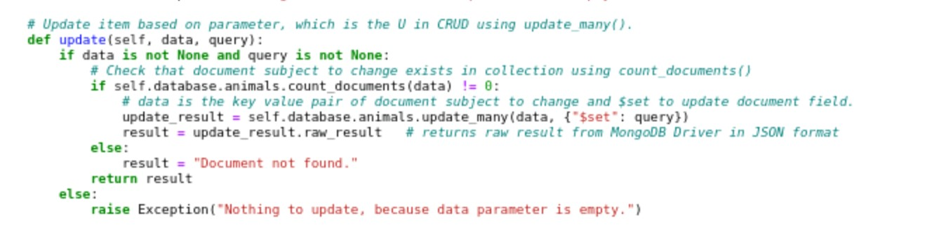

1. The delete function, through a conditional statement, verifies the data used to search for a document is not none, otherwise raising an exception. The function has a nested statement to ensures that the document searched for exists within the database before performing the action of removing a document, based on the queried criteria, using delete_many(). To confirm the removal of the document, the results need to include raw_result() to be in JSON format or else you will get a python.result objectid message.

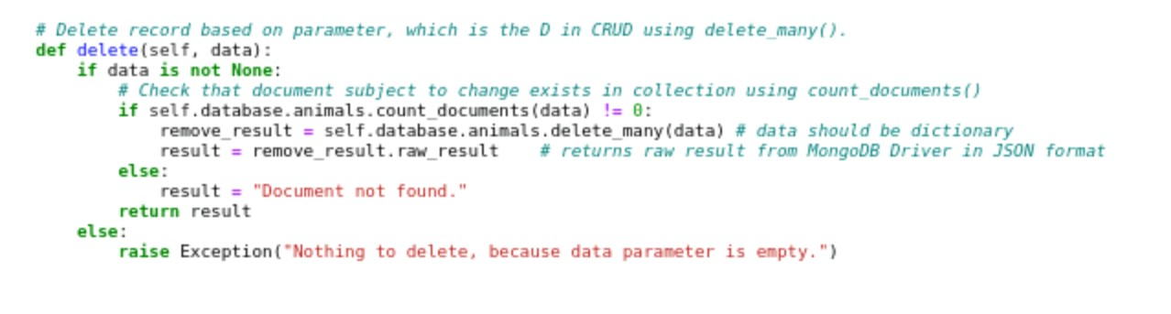

### Test

*The CRUD class is tested to ensure its fully functional and able to access, manage, and maintain the database. The Python Script tests the functionality of the Python Module which is essential to not only ensuring a successful connection between users and the database but ensuring the data queried is correctly returned. To do so, we have to test each function of our CRUD class.*

1. *To begin, import your CRUD class to test and test the authentication of your login credentials for animal collection in the AAC database.*
   1. *Remember to pass the first parameter as your username and the second parameter as your password. All functions produce exceptions for empty parameters.*

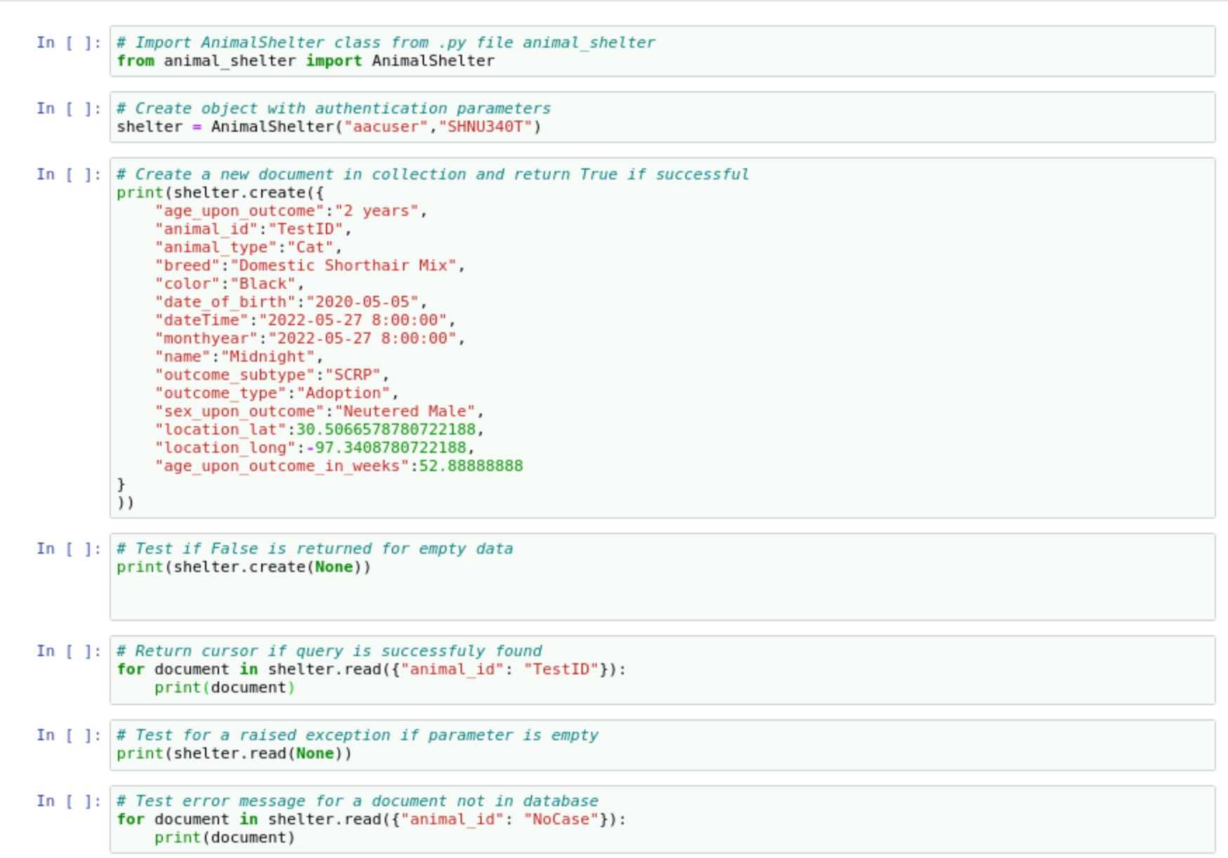

1. *Test the create function in the CRUD class by printing the results the function. Use the structure of yourcreatedobject.function({“key”: “value”, …}). The result should be True. You can also test by passing a “None” parameter to verify the application raises an exception.*

**

1. *Test the read function in the CRUD class by calling the function to read a criterion of a document you have chosen and print. Use the structure yourobject.function({“key”: “value”}). This test should print all the documents with your chosen criteria. If you choose to find your newly created document, then your result should reflect its criteria. You can also test by passing a “None” parameter to verify the application raises an exception.*

**

1. *Test the update function by choosing a key and value for the document you wish to update and for the criteria you wish to update to and print. Remember, this function holds two parameters. Use the structure yourobject.function({“key”: “value”}, {“criteria key”: “updated value”}). Your result should confirm how many documents were modified and that the document was updated in JSON format. To further verify, you can once again test the read function passing the updated document as a parameter. Your chosen criteria should reflect the updated version. You can also test by passing empty or nonexistent documents as parameters to verify the application raises an exception.*

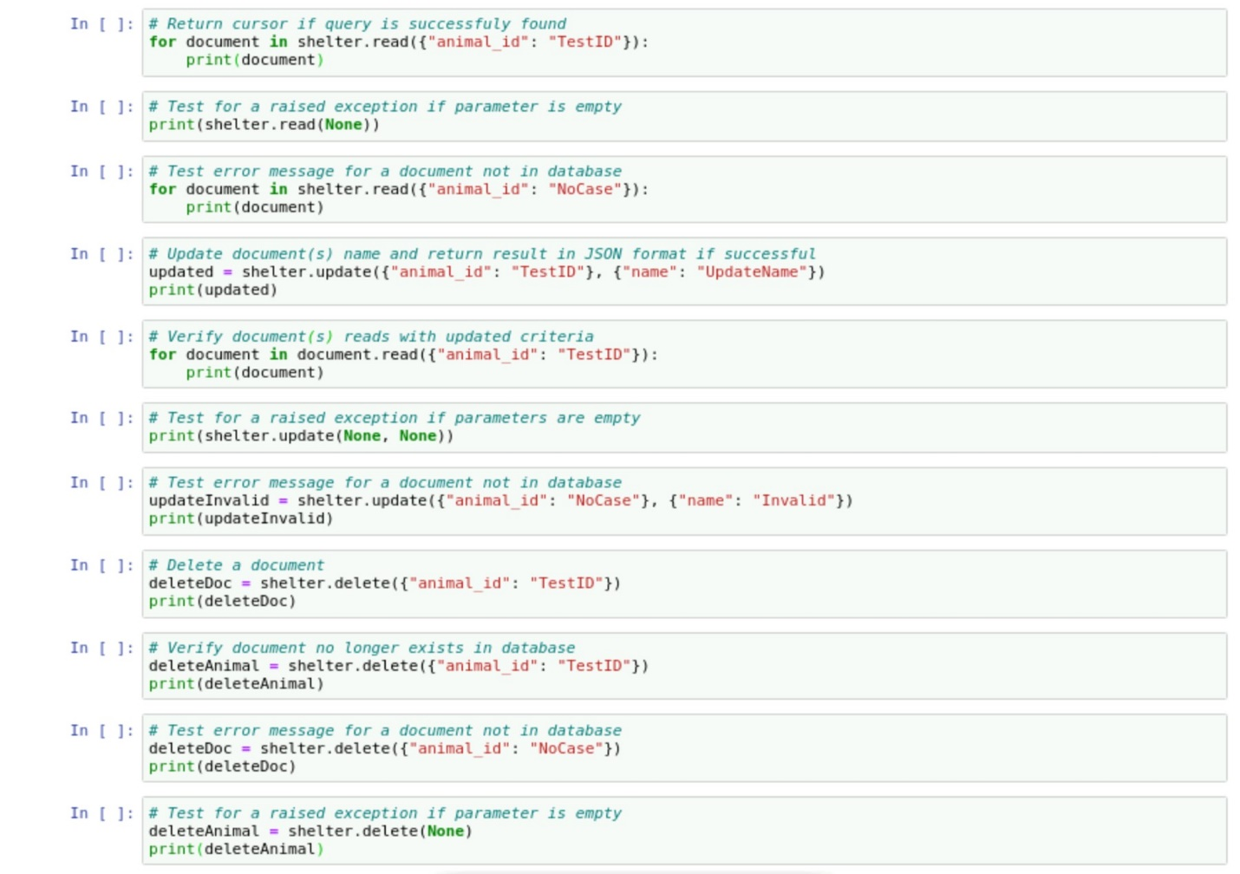

1. *Test the delete function by choosing a key and value for the document you wish to remove from the database and print. Use the structure yourobject. ({“key”: “value”}). Your result should confirm how many documents were found and removed with that key value pair in JSON format. To further verify, test the delete function again using the same key value pair. You should receive a message informing the document is not found. You can also test by passing a “None” or a nonexistent document parameter to verify the application raises an exception.*

**

**Dashboard**

*The Dash Python Code is set up to build a web application dashboard that sends and receives queries and results by calling on the CRUD Python module’s functionality to read data and display results through an interactive dashboard that displays a data table, geolocation chart, and pie chart at their current state.*

1. *Instantiate the CRUD class in the Python module to develop the needed database queries we will build in the steps below. Do not forget to import the Dash frameworks needed to access the Dash Core Components used, as well as PyMongo.*

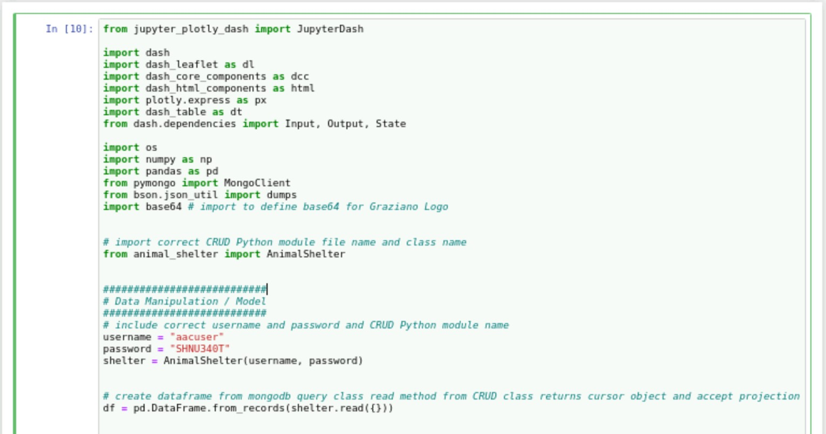

1. *Authenticate the user as part of the CRUD Python module class instantiation.*
   1. *Double check you are correctly hardcoding the username and password for the “aacuser” account.*

**

1. *Query MongoDB using the read() function from the CRUD Python module to retrieve data from the AAC database. This step is important as the applicant is reliant on a successful connection to the CRUD module and in turn MongoDB.*

**

1. *Develop the layout of your dashboard by:*
   1. *Importing client logo*

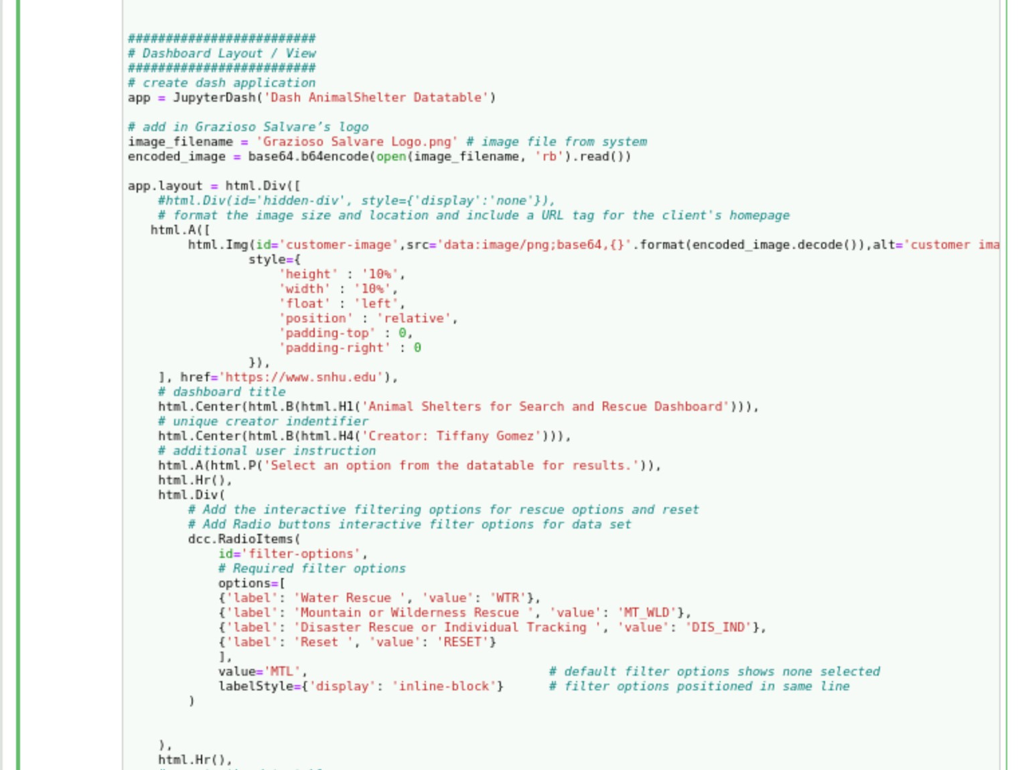

* 1. *Create header for logo with URL tag, title, and unique identifier. In this example, the image of the logo is centered and tagged with SNHU’s homepage. Under the logo are two centered headers of different size for the Dashboard title and unique identifier. To finish, before the inclusion of filter options, is a line of user instructions aligned to the left.*

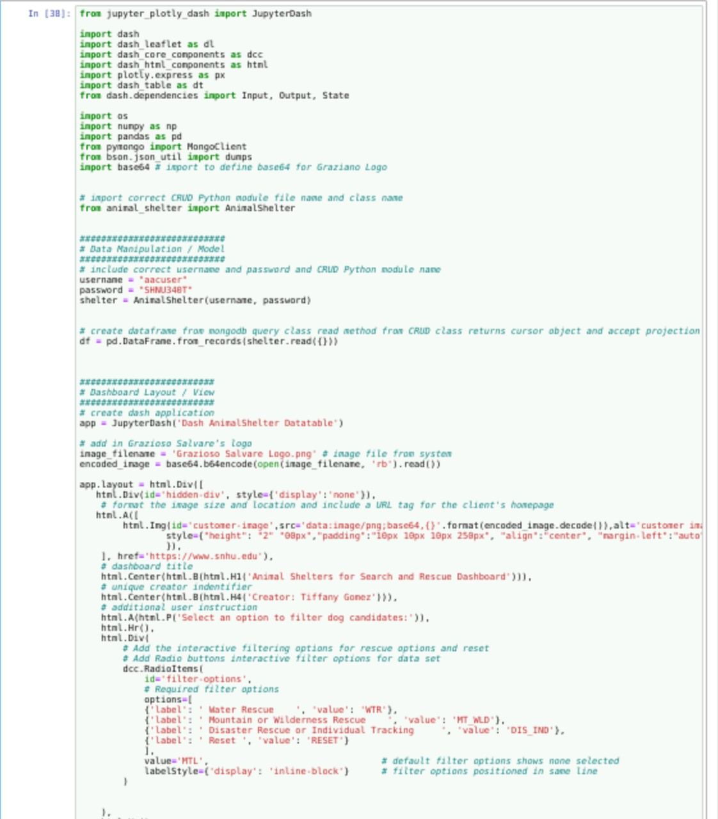

1. *Build interactive options through which users will activate the filters. As we are following a MVC design pattern, the controller pieces need to be developed to create interactive options that provide users with a selection of data based on your filtering functions. A radio item was developed in the example below using the queries developed in step 8a.*

**

* 1. *Run the program to ensure the data table created responds to the selection input from the radio item to update the data in the table accordingly.*
     1. *It is recommended to keep track of ids for the dashboard’s data frame, geolocation map, and pie chart, as well as labels and values. During callbacks errors may occur for incorrect ids and the creation of the charts may fail without correctly including labels and values.*

1. *Create an unfiltered data table that views the Austin Animal Center Outcomes (AAC) data set. To populate the data from the database onto the table, the read() function is called from the CRUD Python Module to query the entire database and bring in the data from MongoDB.*

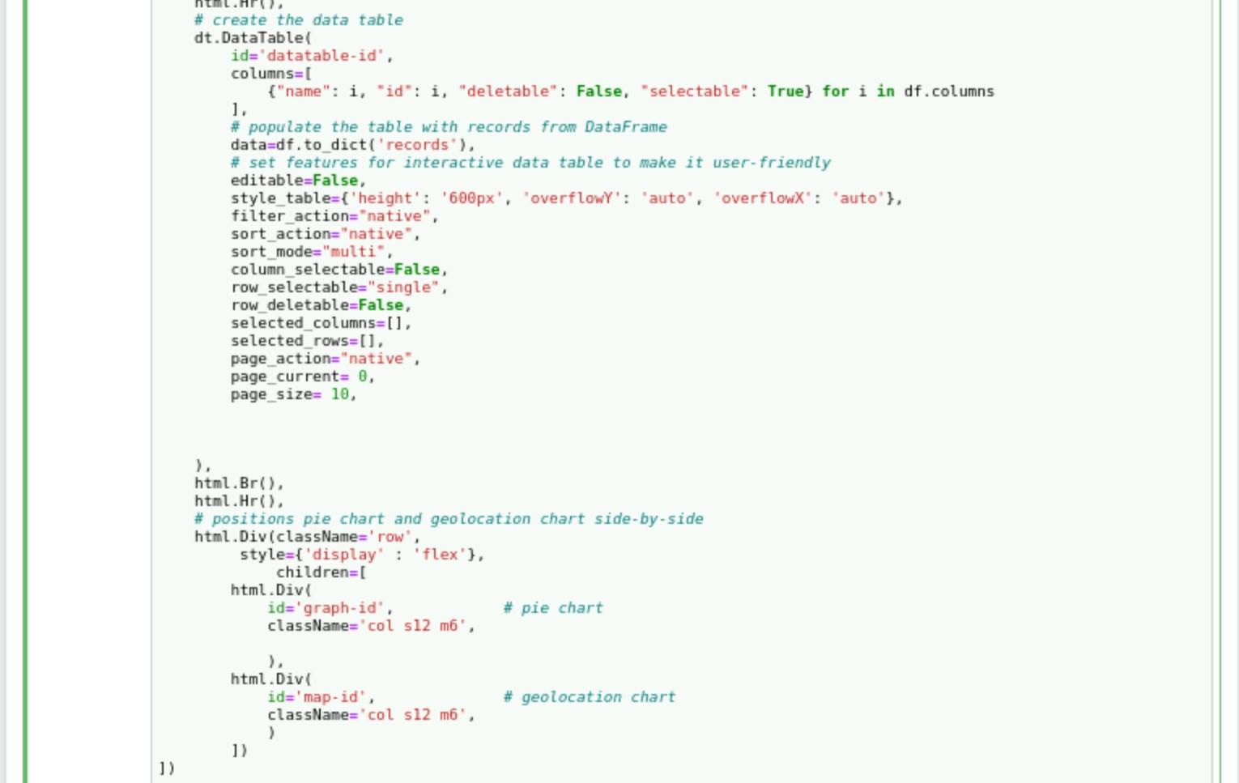

* 1. *Set the type of filter options for sorting you want the data table to include. You can edit the style of the table as well as the cells. You may use the following code as a template and adjust each feature to your preference. For example, this application limits the data table to 10 entries per page, does not allow users to delete rows or select columns, allows users to select a single row (entry) from the table, limits the maximum width of a cell and uses ellipsis to represent cut data, creates vertical and horizontal scroll bars, and allows users to sort the order of displayed items.*

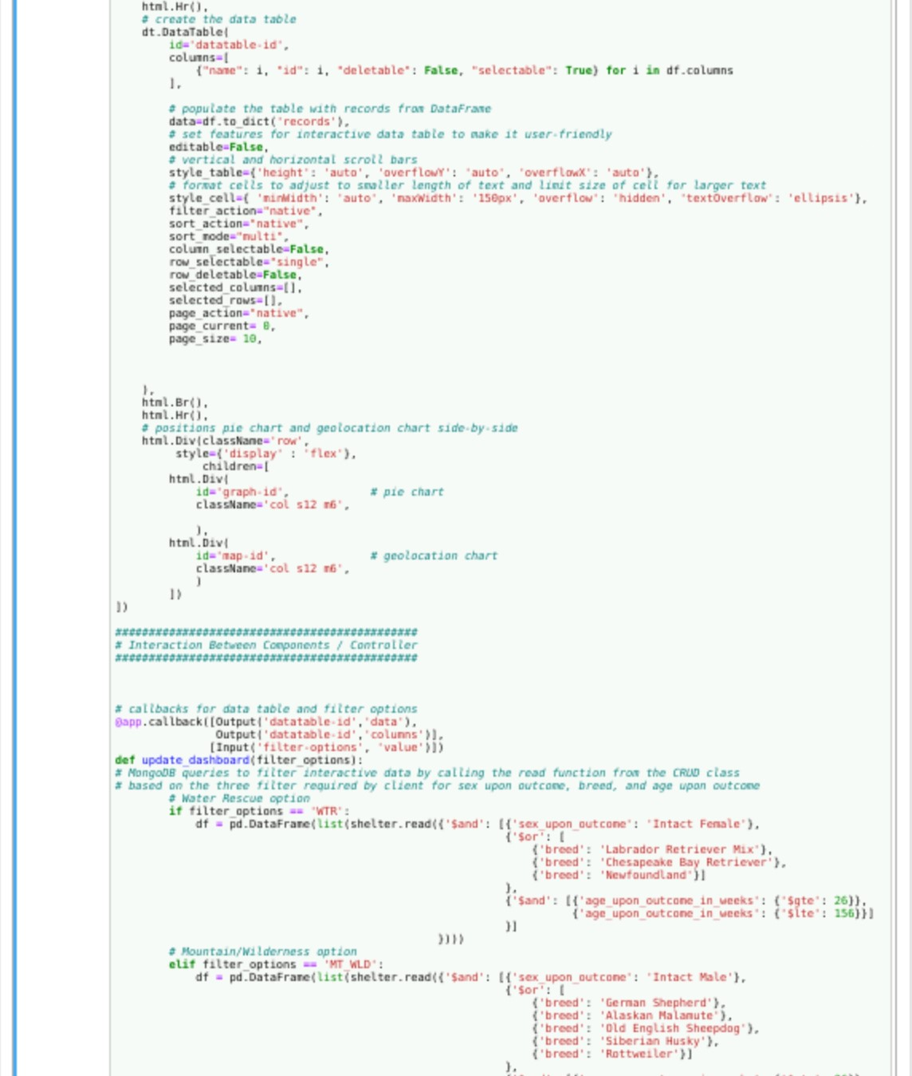

1. *Create an application callback that filters the data frame with all the complete data retrieved from all animal shelters and to ensure data table always reflects user selected filter options. Remember to include the correct id for the data frame and set filter options.*

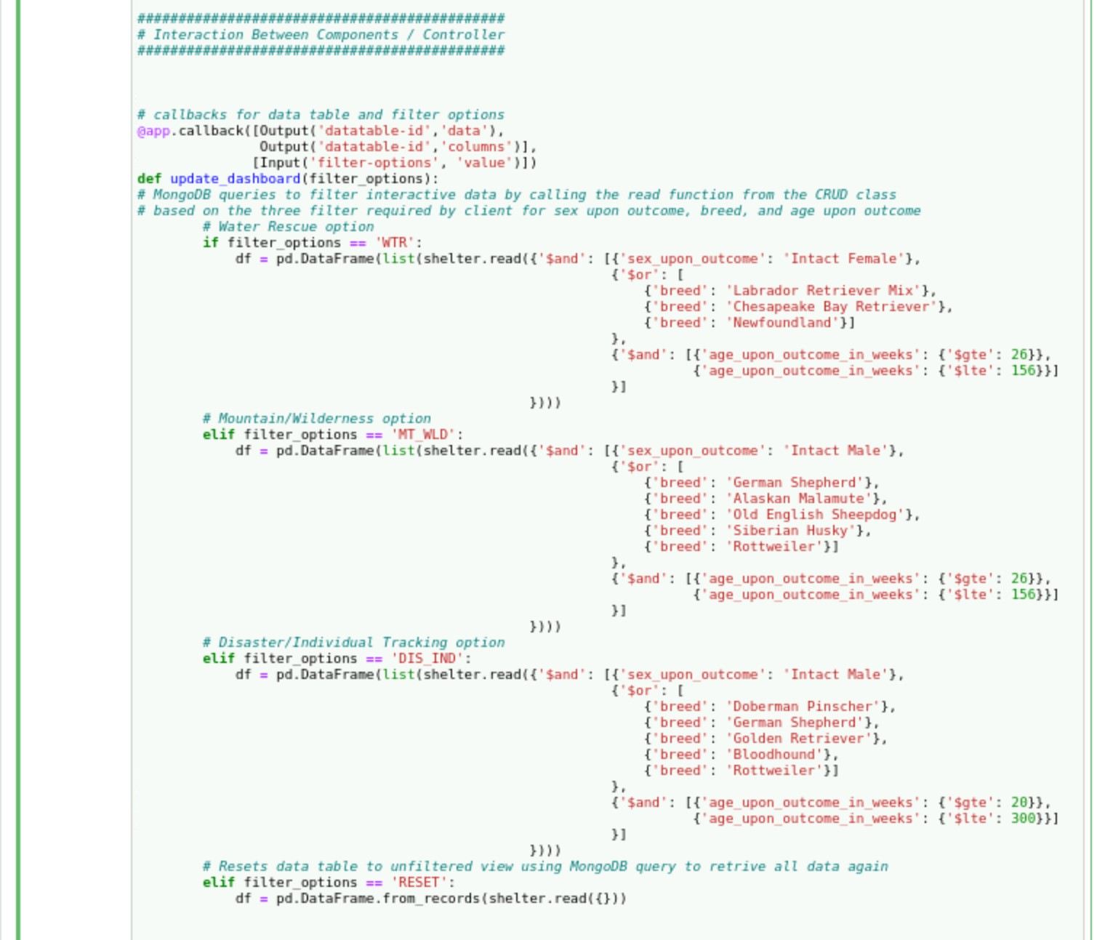

1. *Develop queries that allow users to filter the database based on the client’s required filter functionality based on the Rescue Type and Preferred Dog Breeds Table shown below along with the subsequent constructed queries.*

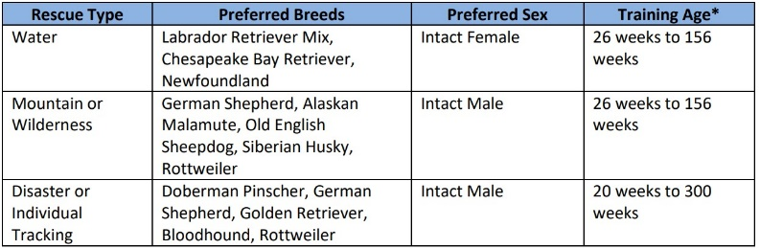

* 1. *Note these are complex queries as searches are grouped together. Ensure your syntax is correct to avoid errors.*

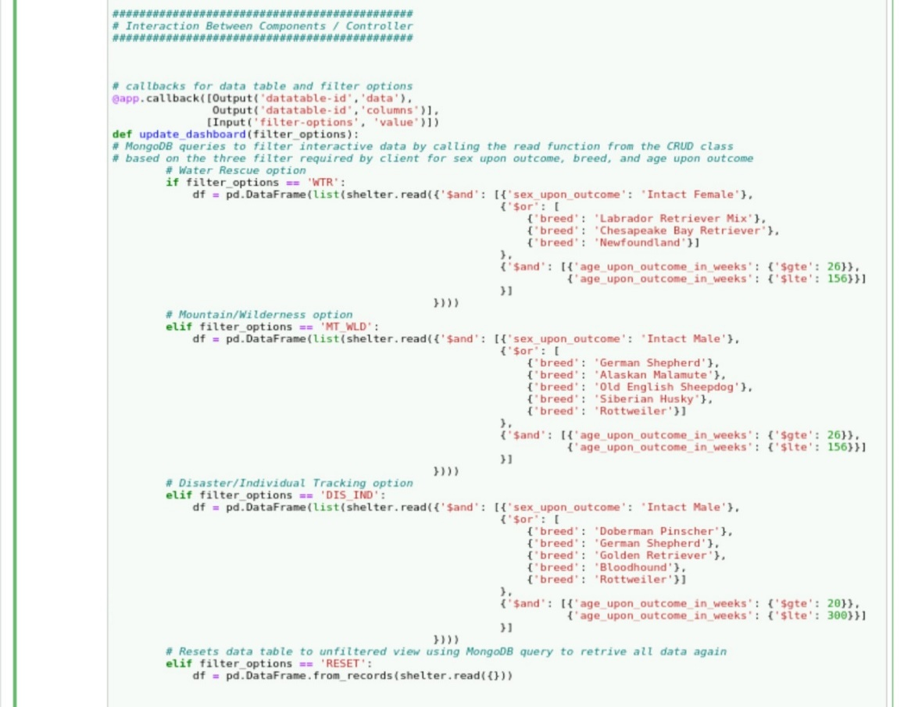

* + 1. *Do not forget to include an option to reset the dashboard to the original unfiltered view. To do so MongoDB must again be queried to retrieve all data using the CRUD Python module’s read() function.*

**

* 1. *It is recommended that after this step you run the program to ensure the dashboard filter options properly retrieve data from the database.*
     1. *To troubleshoot, refer back to the CRUD Python module and test script to ensure functionality produces required results. If so, then refer back to step 2a. under this Dashboard section to ensure you are correctly connecting to the Python Module and in turn the MongoDB database.*

1. *Add widgets for dynamic presentations of retrieved data using callbacks to connect to the data table itself and reflect the correct updates.*
   1. *Geolocation chart that shows the position of a user’s selected entry on a map. If a user does not select a row, then by default the location of the first data table entry is reflected in the map. Since our feature filtered options is set to only allow users a single row selection, it is only necessary to include logic for a single selected row. The map uses the coordinates for latitude and longitude found in columns 13 and 14 for the animal location. The marker uses those same coordinates to mark the position in map. Use tooltip to show animal breed when hovering over mark. You may populate the pop up box to include any data from your selection using the appropriate columns.*

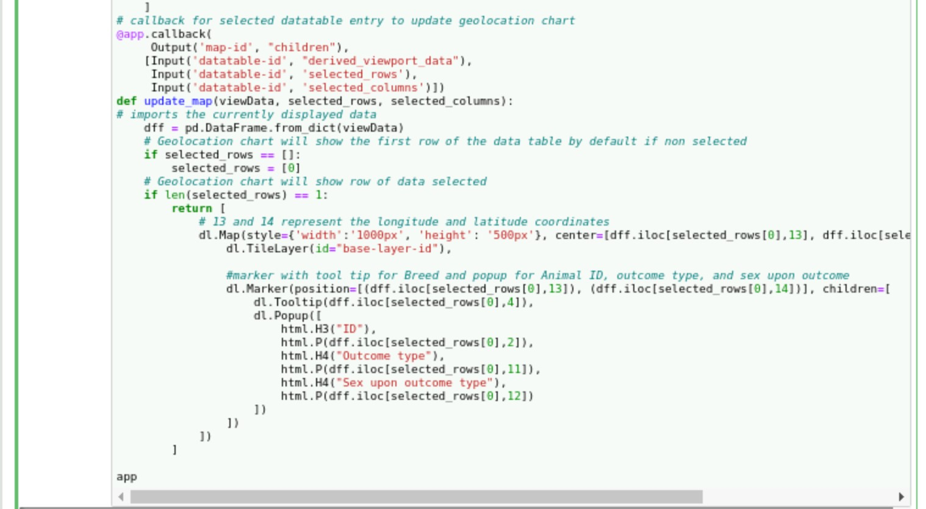

* + 1. *For a geolocation chart that dynamically responds to the filtering options, create an application callback that updates the geolocation chart with the first item in unfiltered view data table or first item in category if a selection is not yet chosen by user.*

**

* 1. *A pie chart that reflects the percentage of a breed and, in accordance with a user’s interaction with the available features, will adjust to reflect percentage of breed per category filter selection and single entry selection in the category.* 
     1. Visit [Built-in continuous color scales in Python (plotly.com)](https://plotly.com/python/builtin-colorscales/) website for a list of Plotly sequential colors.
     2. Note the parameters require an index of names and an array of values. Verify the chart populates to then add logic and breed data. You may add different criteria as your target data.

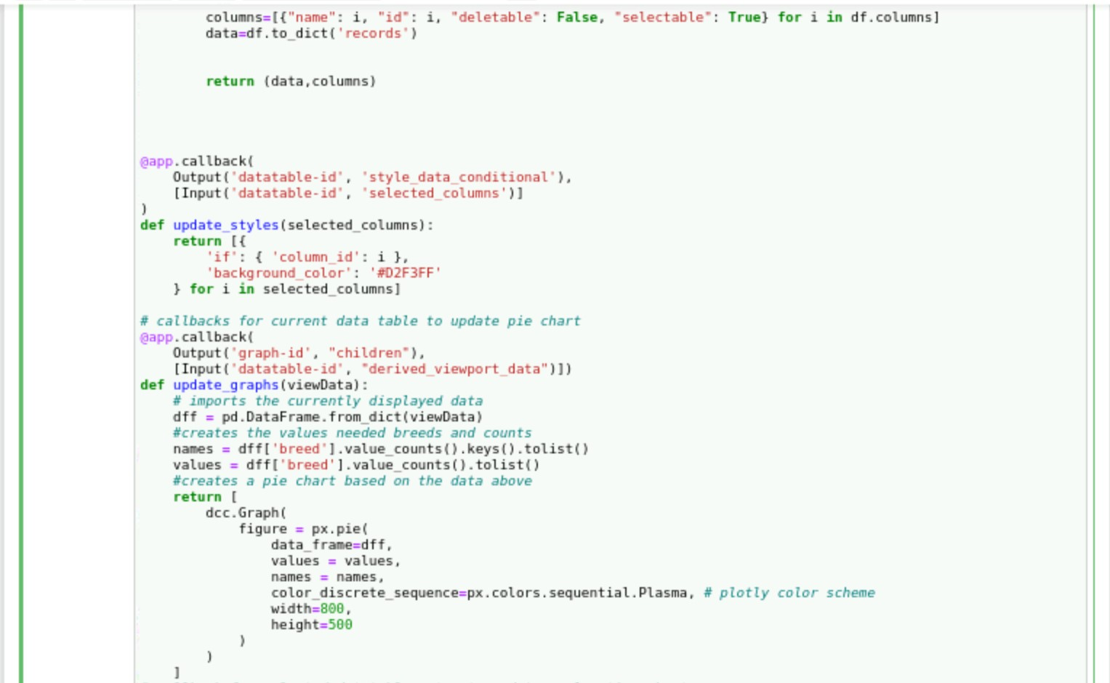

* + 1. *A pie chart that dynamically responds to the filtering options. Create an application callback that automatically updates the chart data to match user chosen filtered options.*

**

### Screenshots

**CRUD Python Module and Test Script**

* *Please refer to the screenshots of test.ipynb (Python Test Script) below to see a working example of the CRUD Python Module.*

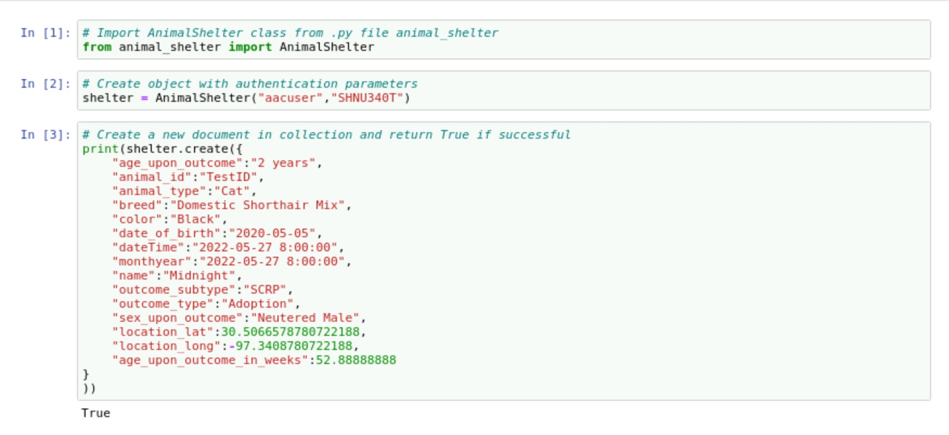

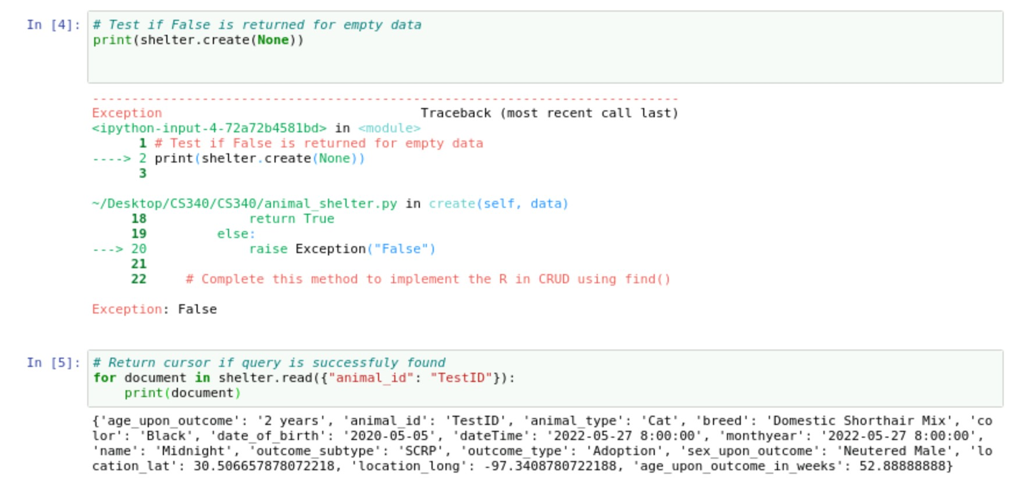

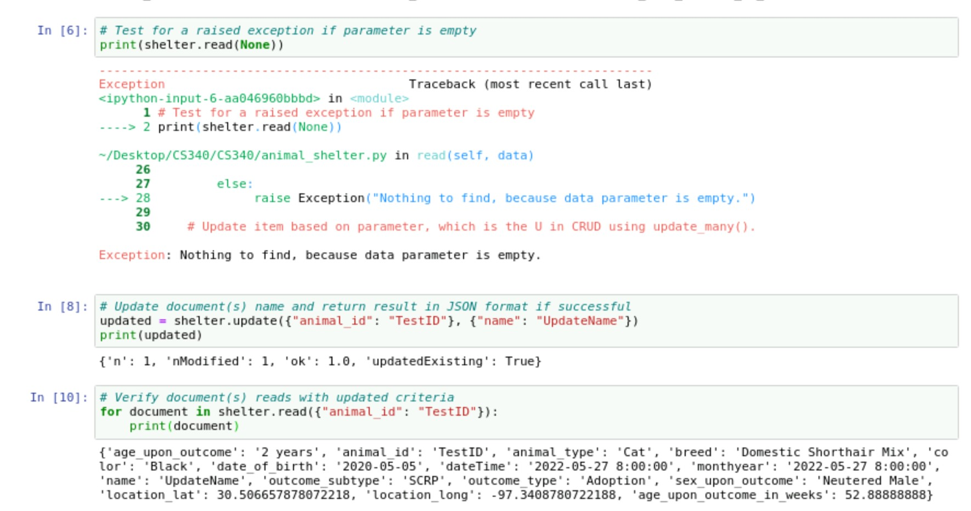

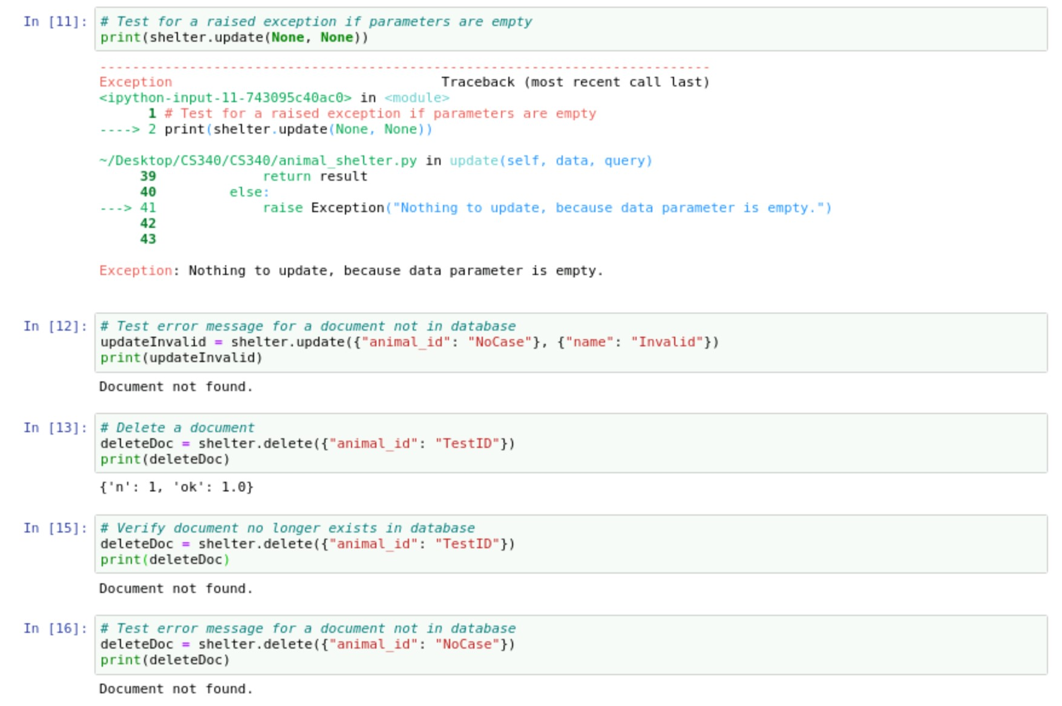

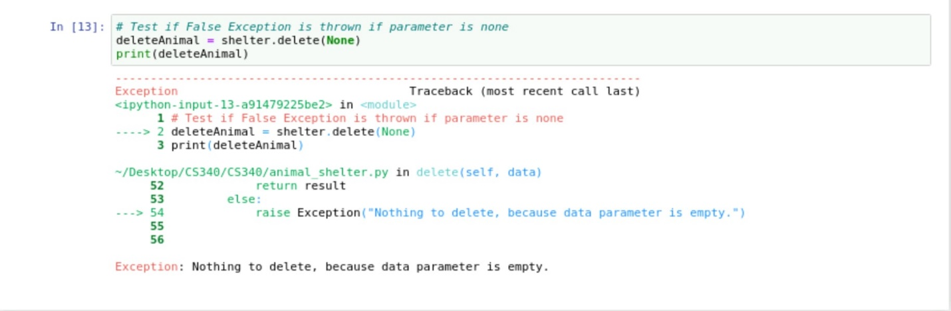

* *Python class animal_shelter.py*

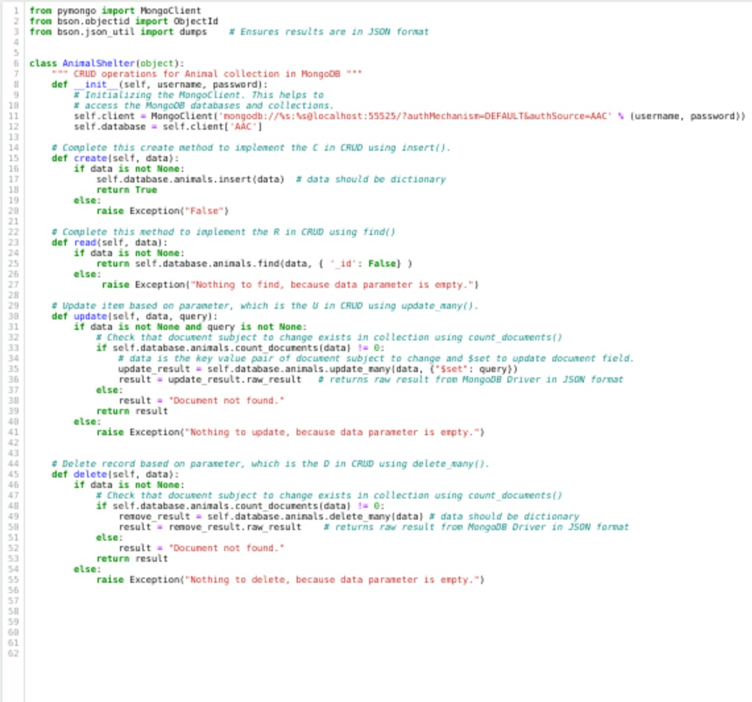

**Application Dashboard and Python Code**

* *Unfiltered view of dashboard:*

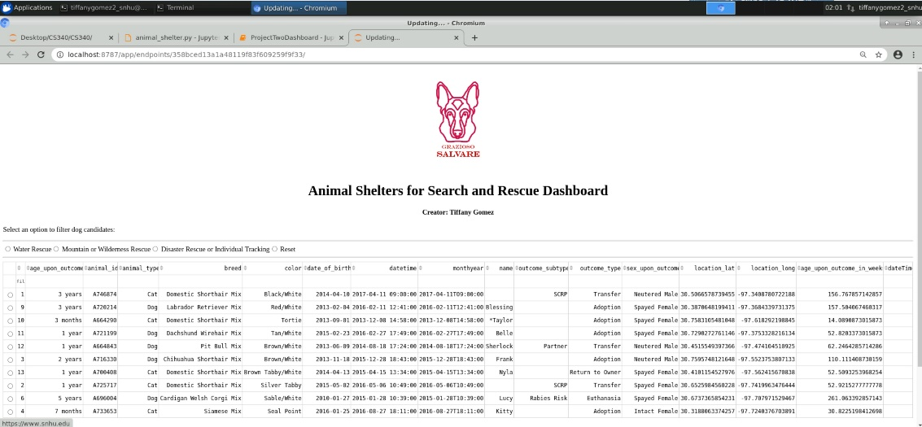

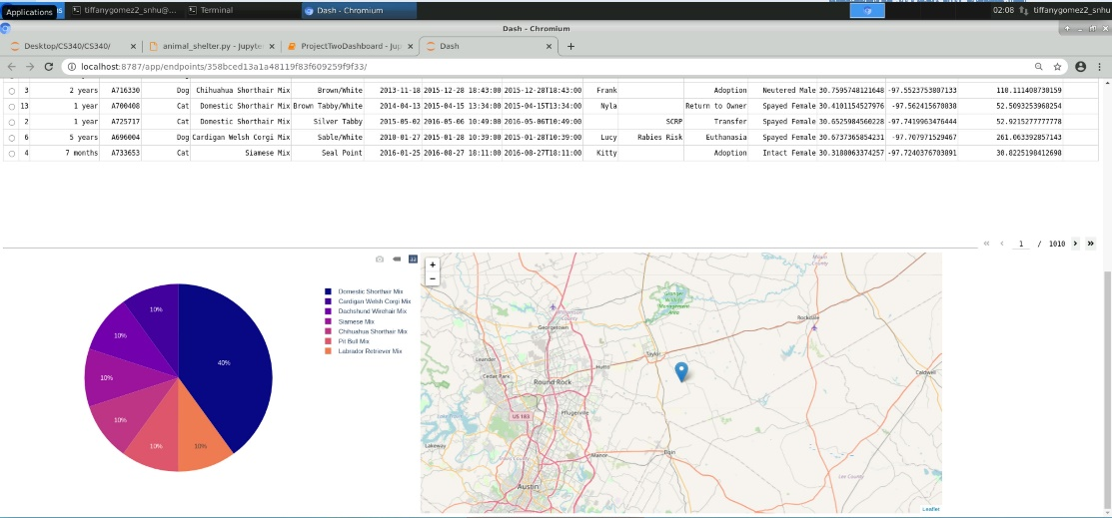

* + Unfiltered data table but with user enacting a sort order. Shows the same unfiltered dashboard but with entries in ascending order.

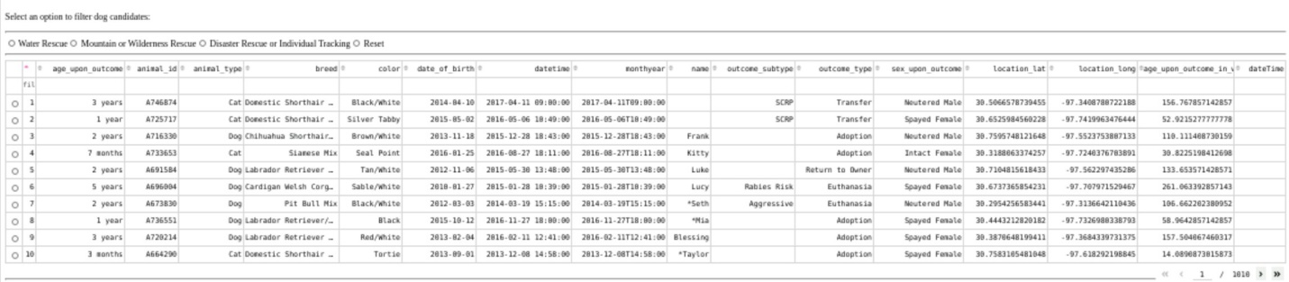

* *As per clients request, The Grazioso Salvare logo with a URL anchor tag of the client’s home page is included along with my unique identifier as the creator of this dashboard. Below are the interactive filter options using radio items to filter the AAC data set by 3 different rescue options with an added reset option to return all widgets to their original state. A datatable, a geolocation chart, and a pie chart that dynamically respond to the filtering options are included. Please review the screencast to see:*
  + - 1. *If nothing is selected, an unfiltered view of the dashboard. This includes a data table with a maximum of 10 rows, a pie chart showcasing the percentage of data for each breed, and a geolocation chart that displays the location of the first entry with the breed name displayed when hovering over the mark and animal information displayed with mark clicked.*
      2. *If the Water Rescue filter option is selected, the user sees an updated data table, pie chart, and geolocation chart that marks a new first entry.*
      3. *If the Mountain or Wilderness Rescue option is selected, , the user sees an updated data table, pie chart, and geolocation chart that marks a new first entry.*
      4. *If the Disaster Rescue or Individual Tracking option is selected, the user sees an updated data table, pie chart, and geolocation chart that marks a new first entry.*
      5. *If the Reset option is selected, the user sees the data table, pie chart, and geolocation chart mark return to the original unfiltered state.*
      6. *If an entry is selected from the data table, the user sees updated charts that reflect the new entry.*
      7. *If the The Grazioso Salvare logo is selected, the user is taken to the SNHU homepage website.*

**SCREENCAST**

**[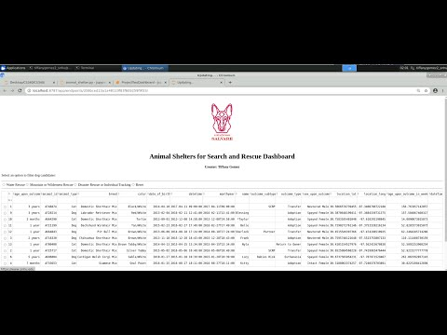](https://www.youtube.com/embed/IjTbbHFKD8c?feature=oembed)**

* *ProjectTwoDashboard.ipynb*





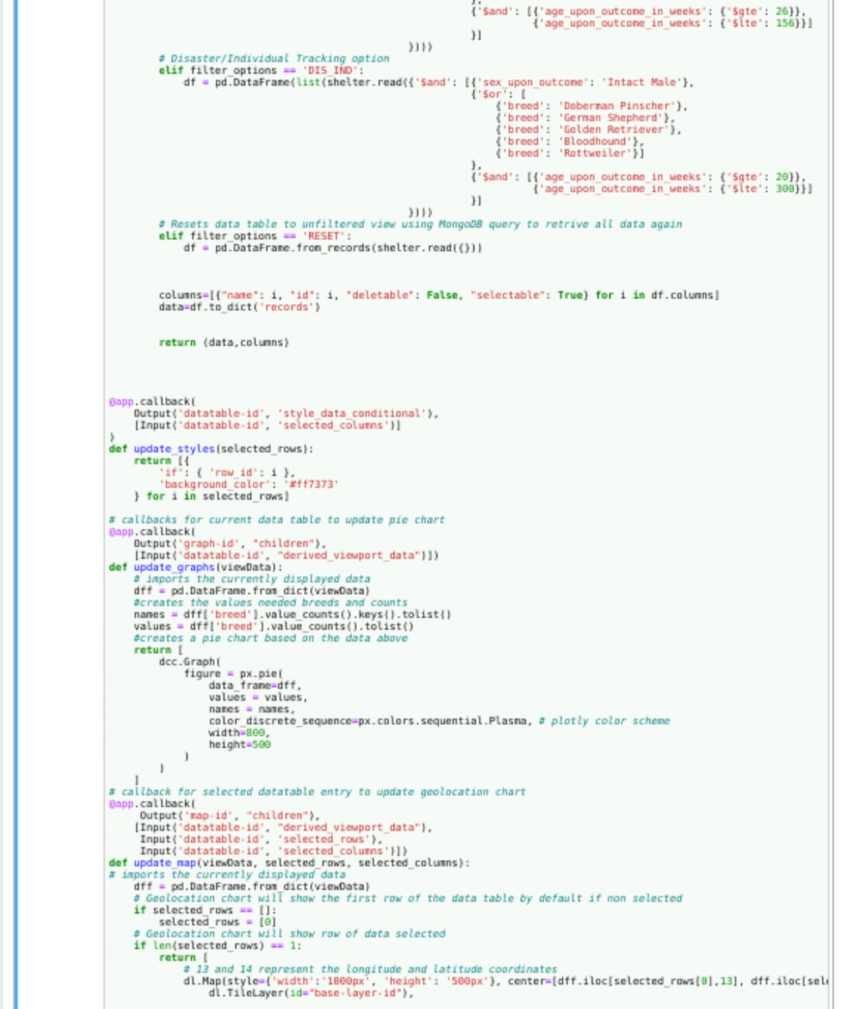

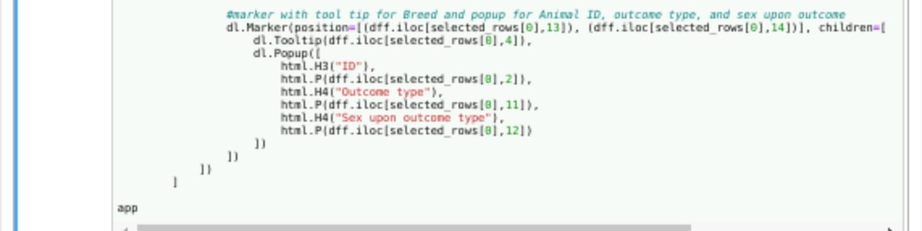

## Roadmap/Features (Optional)

* *Proposed features*
  + *Modify the geolocation chart not only a pin with animal location on map but also include actual address using number, street, and city format.*
  + *Add function to allow users to select more than one entry to reflect on charts.*
  + *Expand filter options to allows users to further query each category based on other criteria.*
* *Known Issues*
  + *Running the test file consecutively produces errors for the create function which trickles down to the read function. Editing any testing input and rerunning the test will sometimes also emit errors to parts of the test where there were none. At the moment, the only temporary solution is to shut down the kernels and close the terminal, then reopen the terminal, check the status of Mongo, and open to rerun the tests.*
  + *Using select-row and setting to ‘multi’ instead of ‘single’ allows users to select more than one animal entry but slows the program down. Due to this reason, I made the decision to only allow users a single selection per geolocation chart.*

## Contact

Tiffany Gomez

Tiffany.gomez2@snhu.edu